Create Unit Test Project using Nunit:
- Open VS 2022 -Create New Project-Search Console App-Next
- Give the Project Name as “UnitTest” and click Next.
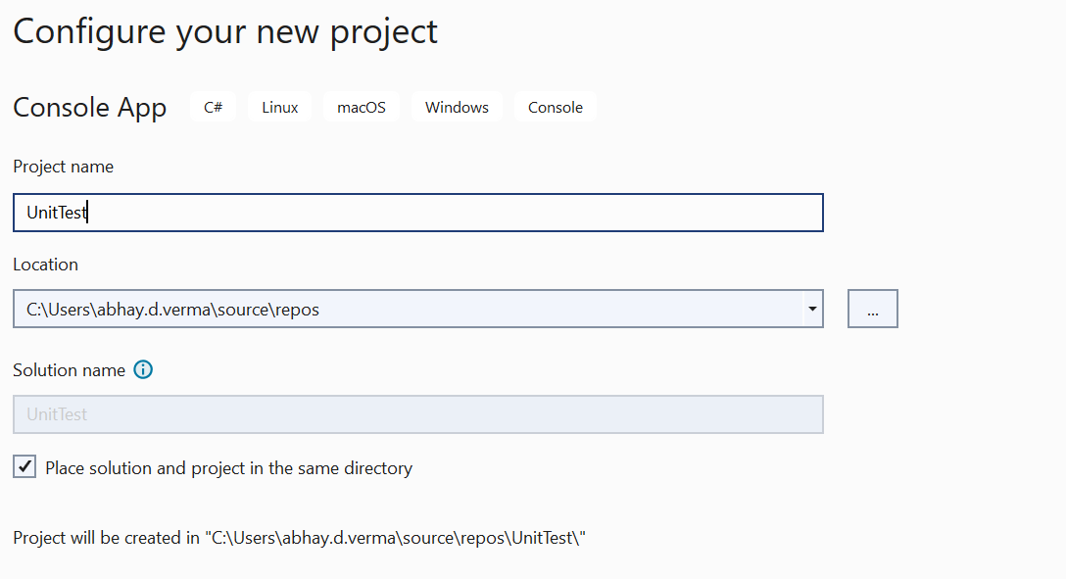
- Add New Class “Employee.cs” with some basic properties.

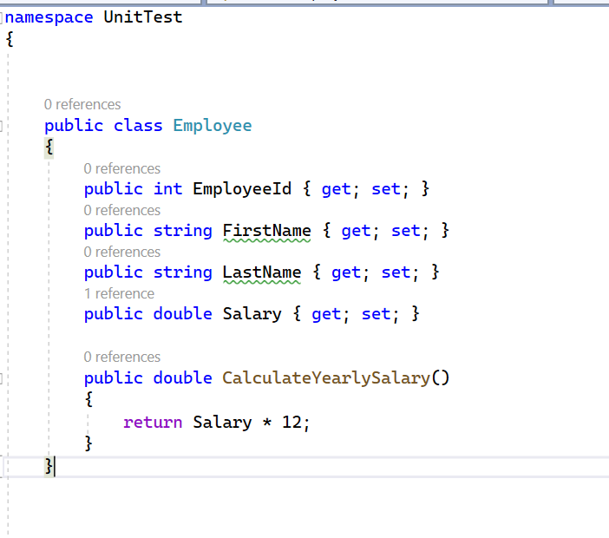
- GO TO Solution explorer and Add new project -search Nunit and choose Nunit test project 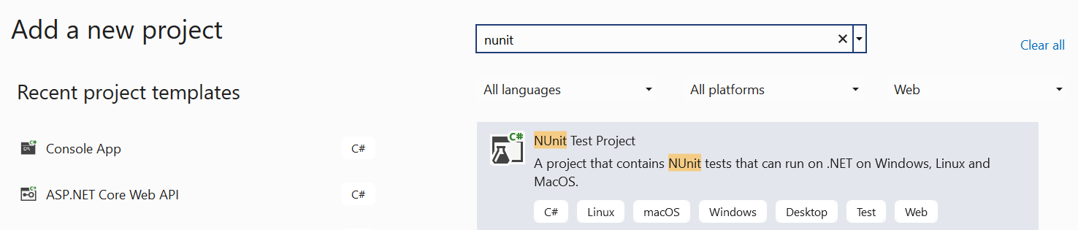
- Give name to the project “NunitTest” and click next 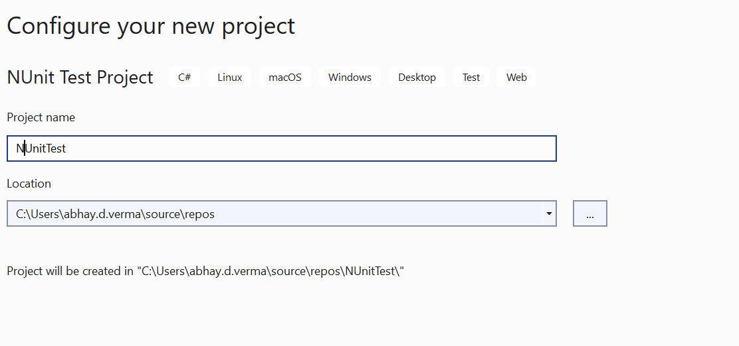

- Right click on “NunitTest” project and add project reference “UnitTest”.

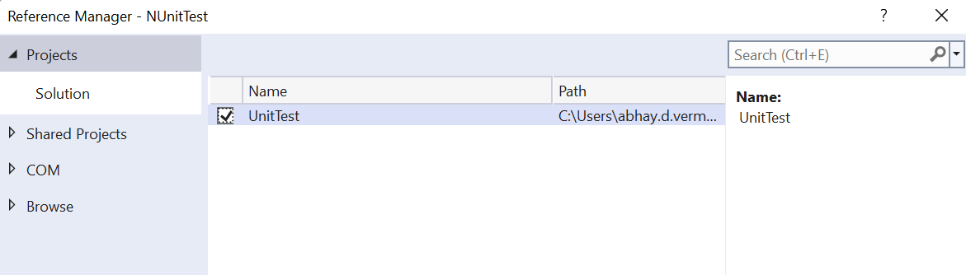

- Open UnitTest1.cs and use the below code for EmployeeTests
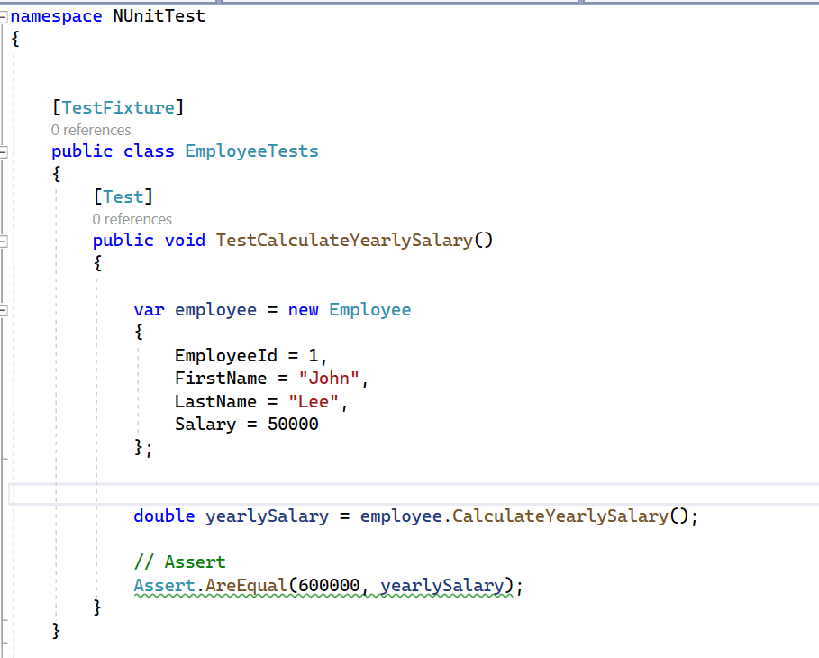

- Go to Test -Run All Test
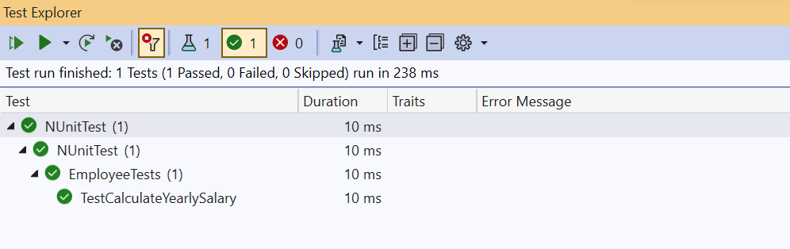

9. The “EmployeeTest”s class will run the “TestCalculateYearlySalary” test, and it should pass since the expected yearly salary (600,000) matches the calculated value from the “CalculateYearlySalary” method of the Employee class.
So here You have written a unit test for the Employee class and verified that the “CalculateYearlySalary” method is working correctly. You can add more tests to cover other methods in the Employee class as needed.

